Take me Home (Film)

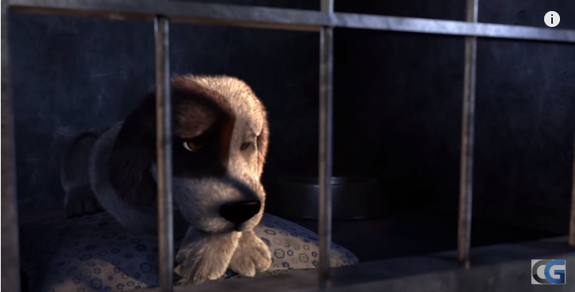 "Take Me Home" is an animated short film created and directed by Nair Archawattana, with a collaboration of talented students at Academy of Arts University.

In a cold, dark dog shelter, a young beagle is waiting for the right one to take him home.

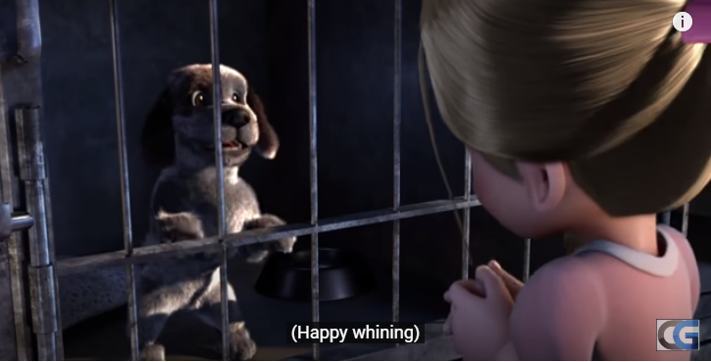 Α touching animated short film In a cold, dark dog shelter, a young beagle is waiting for the right one to take him home. Time passes by, the beagle is getting desperate. Until one day, when hope finally shine upon him. He has to do everything he can to leave the place!

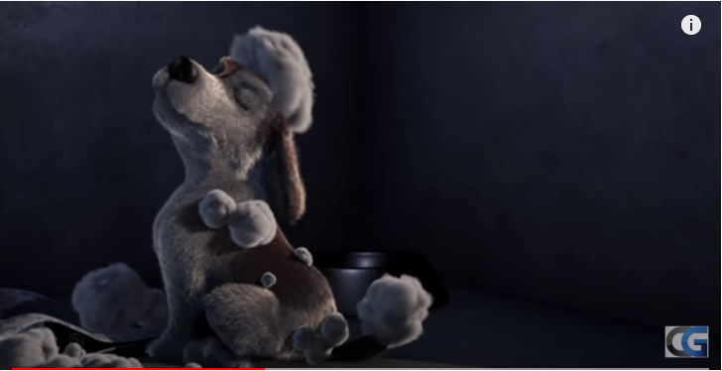 The film is appropriate for all ages because it’s a story of a four-legged animal looking to find a home.

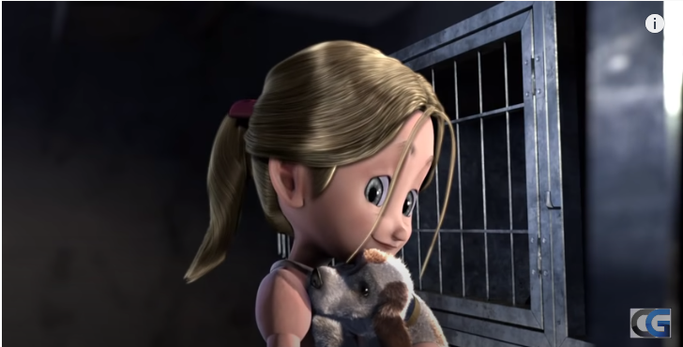 I think is a very moving story for someone who is looking for something that unfortunately not everyone has, a home.
I give to “Take me Home” ***** (Excellent)!

