………………………………………………

**Task 2**

**Write the names of the cities, in pairs**

1. 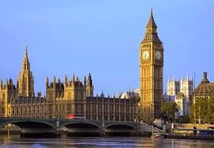
2. 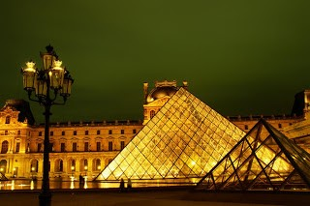
3. 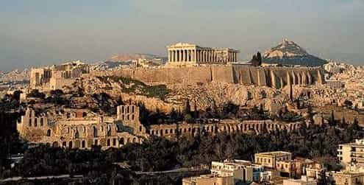
4. **……………………………………………..**
5. **……………………………………………..**
6. **……………………………………………..**

**Task 3**

**Write down the name of each place in English, in pairs.**

1. 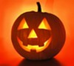
2. 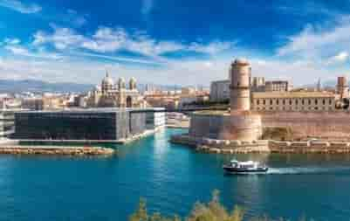
3. 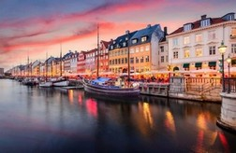
4. 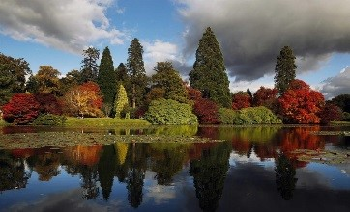
5. **……………………………………………..**
6. **……………………………………………..**
7. **……………………………………………..**
8. **……………………………………………..**

**While-Task**

**Task 1**

1. 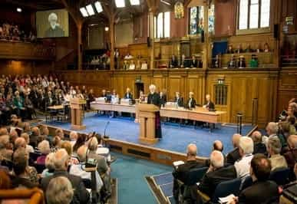
2. 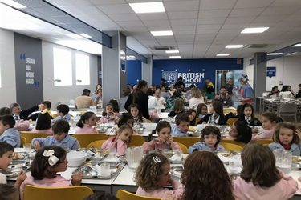
3. 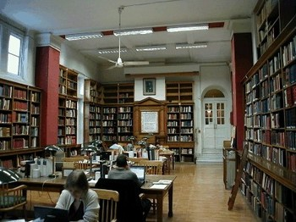
4. 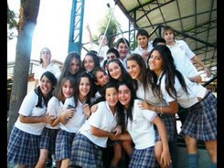
5. 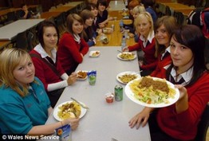
6. 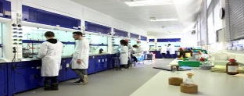

* **British school**
* **Assembly Hall**
* **British canteen**
* **British dining room**
* **Library**
* **Chemistry Lab**