Appendix E: “Task-based lesson”
Based on Bouniol (2004) and Ekaterinidi (2020)
Pictures retrieved from:
- https://www.google.com/url?sa=i&url=http%3A%2F%2Fwww.visitgreece.gr%2Fen%2Fmain_cities%2Fpatras&psig
- https://www.google.com/url?sa=i&url=https%3A%2F%2Fwestern-greece.com%2Fpatra
- https://www.google.com/url?sa=i&url=https%3A%2F%2Fwww.greeka.com
- https://www.google.com/url?sa=i&url=https%3A%2F%2Fwww.ancient.eu%2FAthens%2F&psig
- https://www.google.com/url?sa=i&url=https%3A%2F%2Fweb-greece.gr%2Fdestinations%2Fpatra-achaia
Pre-cycle
NAME EACH PLACE IN ATHENS OR PATRAS
Εικόνα 1
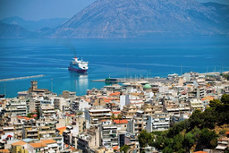
Εικόνα 2
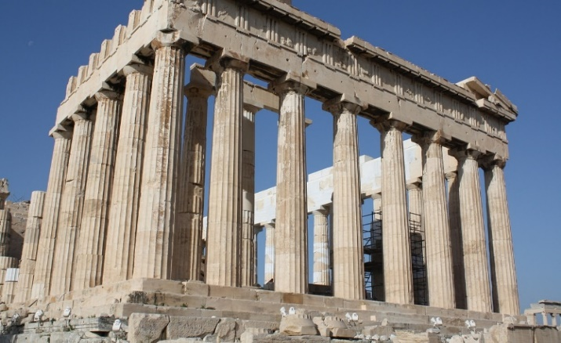
Εικόνα 3
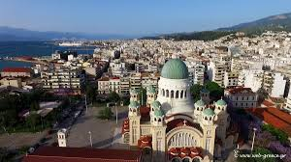
Εικόνα 4
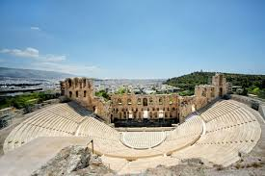
Εικόνα 5
1……………………………………………….
2……………………………………………….
3……………………………………………….
4……………………………………………….
5……………………………………………….

While-cycle
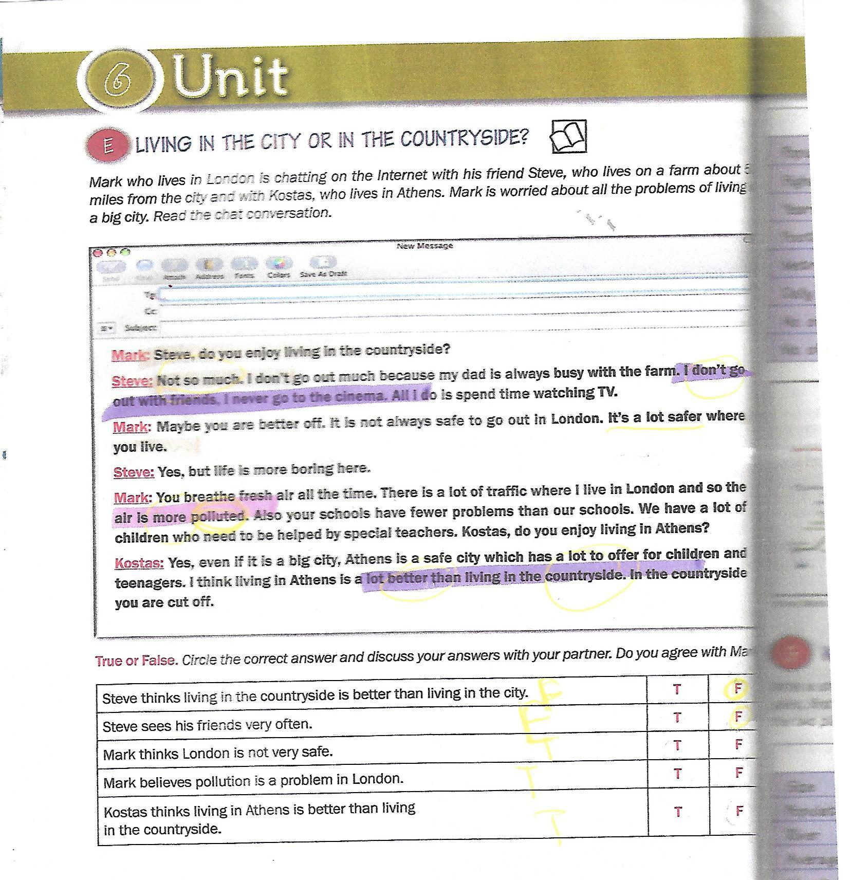
Group A
Read the following dialogue and exchange information with your peers in Group B to complete the gaps.
Group B
Read the following dialogue and exchange information with your classmates in Group A to fill in the gaps

Group A
Α : Do you enjoy 1…………in Athens?
B: Yes, very much. I go out with my friends. 2…………lots of shopping and 3 ………… films at cinemas. I also 4…………museums.
A: It is not always 5………… to go out in Athens. It’s a lot 6…………
where you live.
B: Yes, life in Patras, is 7…………, too.
A: You 8…………fresh air all the time.
B: There is a lot of 9…………where I live and so the air is more polluted. Do you enjoy living in Patras, then?
A: Yes, Patras is a safe city but does not have as many 10…………
as Athens.
B: I think 11…………in Athens is a better than living in Patras, where there are 12 …………
things to do and see.

Group B
A: Do you enjoy 1…………in Athens?
B: Yes, very much. I (2)………… with my friends. I do lots of 3…………and watch 4…………at cinemas.
A: It is not 5 …………safe to go out in Athens. It’s a lot safer where you 6 …………
B: Yes, 7…………in Patras is exciting, too.
A:You breath 8 ………… air all the time. There is a lot of traffic where I live in Athens and so the 9…………is more polluted. Do you enjoy 10…………in Patras?
B: Yes, Patras is a safe city, but it does not have many museums or shops as 11…………does. I think living in Athens is a lot better than 12 …………in Patras, where there are few things to 13…………and 14…………
Post-cycle
Write an e-mail describing the place you live in. You can use the e-mail on page 38, Activity B, in your coursebook as a model.

