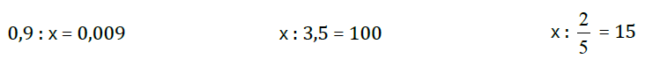



(25 + 35) – χ = 22 + 23 (0,5 + 7,5) – χ = 4 555 * χ = 55

Χ – (17 + 23 ) = 10 χ- (23 – 7,8 ) = 5

χ- (250 : 10) =20  - χ =  χ -  = 



**Λύνω τις παραπάνω εξισώσεις**