CAI LUN

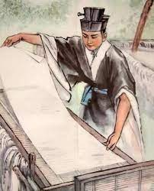
Cai Lun formerly romanized as Ts'ai Lun, was a Chinese eunuch court official of the Eastern Han dynasty. He is traditionally known for the invention he made, the paper, but, he has also made a lot of other inventions!

He was born in Guiyang Commandery, Han Empire (modern-day Leiyang, Hunan province, China). He died in 121, in the Palace Han of Louogiang when he was 73 years old. He died because someone gave him poison to drink.

Cai Lun is one of the most important inventors of all time because he invented the paper! If we think what the world would be like without the paper we will be really surprised!!!

