Story Writing for ST’ Class Story 1 “An Adventure in the Forest”
*Read the comic. It’s the beginning of the story. Write the story based on the pictures and give your own ending.
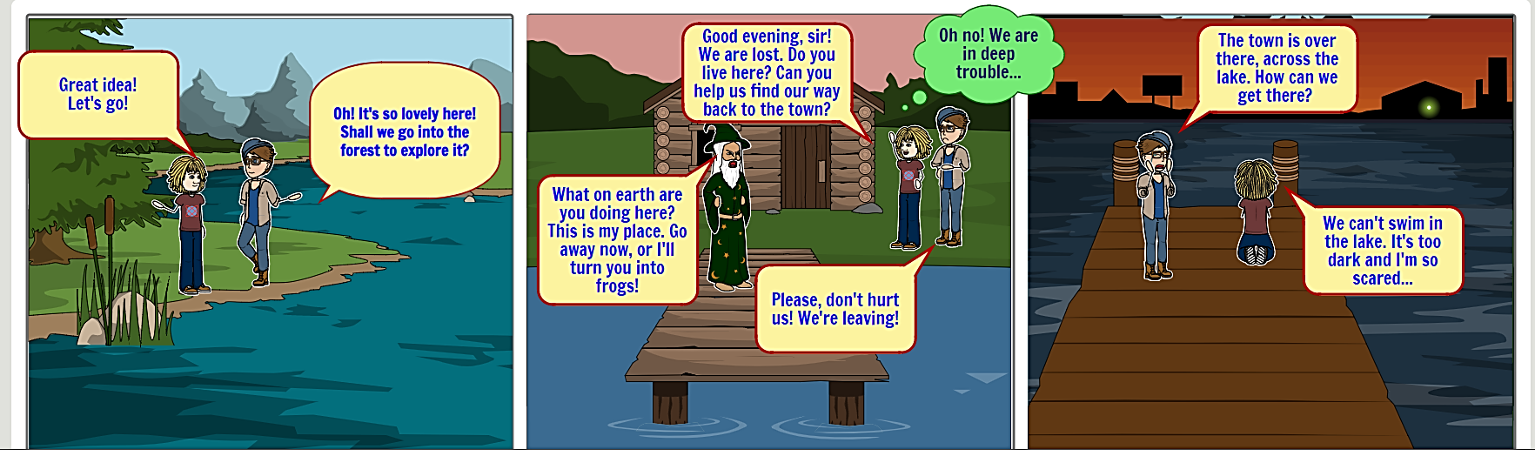
REMEMBER: Before you start writing ask yourself questions. Where?/When?/How?/Who?/What?/…
One evening two young children decided to go into the forest and explore it. Because of their enthusiastic, they lost their way for home. They met a curious man, who was wearing magician clothes. Children asked him if he could help them. The man got angry and told them to go away, because he would turned them into frogs. Children panicked and ran far away. They arrived to a lake. They had to pass this lake, but kids couldn’t. They were cold and scared. They stayed there all the night. The next day kids found a boat. They thought that it was the only way to return home, so they stole it without thinking the consequences. They owner of the boat saw them and called the police. When kids arrived to the town they had to face the police and their parents. Eventually they managed to solve their problems and understood that we mustn’t steal anything and we must always take with us a compass and a map. _________________________________________________________________________________________________________________________________________________________________________________________________________________________________Chrysi Chasouraki st 2 _____________________________________________________________________________________________________________________________________________________________________________________________________________________________________________________________________________________________________________________________________________________________________________________________________________________________________________________________________________________________________________________________________________________________________________________________________________________________________________________________________________________________________________________________________________________________________________________________________________________________________________________________________________________________________________________________________________________________________________________________________________________________________________________________________

