Story Writing for ST’ Class Story 1 “An Adventure in the Forest”
*Read the comic. It’s the beginning of the story. Write the story based on the pictures and give your own ending.
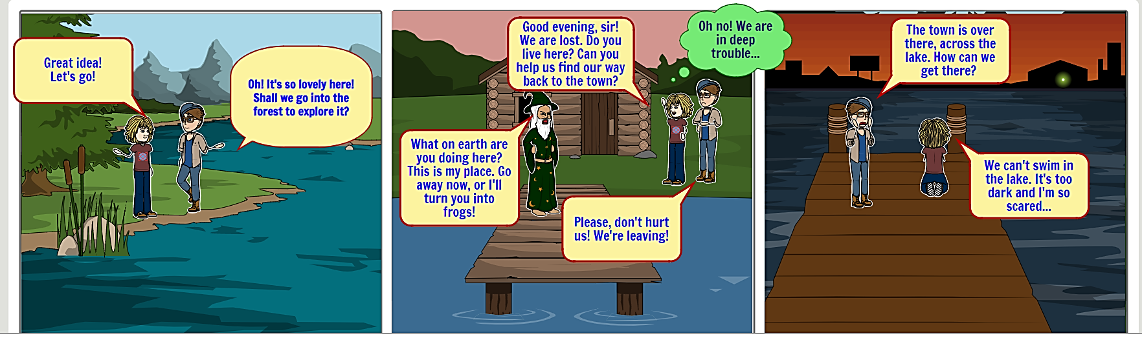
REMEMBER: Before you start writing ask yourself questions. Where?/When?/How?/Who?/What?/…______________________________Boy:We will stay here all night and in the morning we will see what we will do.
Girl:Ok but I am afraid
Boy:Don’t worry
The next morning.
Boy:Good morning.How are you?
Girl:Good morning.I am fine.Finally what are we going to do?
Boy:I don’t know.How about we walk a little lest we find a shetler?
Girl:Oh! This is a good idea. I agree.
They walked until noon but got tired.They saw a man in a boat.
Girl:Hello sir
Sir:Hello guys.Are you lost?
Boy:Yes,can you help us?
Sir:Yes,get on the boat.
They:Thank you very much
Eventually the man went to their house and they all lived well
And we better.

_______________________________________________________________________________________________________________________________________________________________________________________________________________________________________________________________________________________________________________________________________________________________________________________________________________________________________________________________________________________________________________________________________________________________________________________________________________________________________________________________________________________________________________________________________________________________________________________________________________________________________________________________________________________________________________________________________________________________________________________________________________________________________________________________________________________________________________________________________________________________________________________________________________________________________________________________

