David J. Wheeler
Inventor of Assembly Language

David Wheeler was born in 9th of February on 1927. He is known for his abilities with computers, and specifically, microprocessors. He became a computer scientist, and professor of computer science at the University of Cambridge, where he died in 2004.
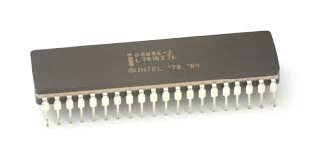
Assembly was a language for the Intel 8086 processor that was used on IBM-PC systems, and it’s used in many programs and operating systems, like Microsoft Windows. It used 0 and 1 symbols and could be read from a human.
David is the father of programming languages, with lots of programs based on his technology. But now, it’s very old-fashioned, with the most programs written in C#, C++, VB or Java. Even the machine that gives you the ability to print this project, uses a little bit of Wheeler’s technique.
John

