Story Writing for ST’ Class Story 1 “An Adventure in the Forest”
*Read the comic. It’s the beginning of the story. Write the story based on the pictures and give your own ending.
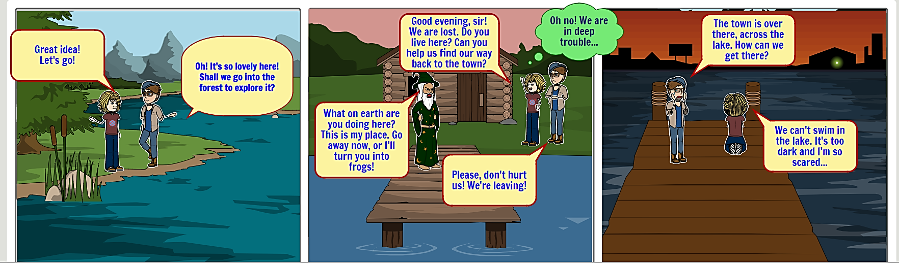
REMEMBER: Before you start writing ask yourself questions. Where?/When?/How?/Who?/What?...______________________________ It was Saturday and the sun was shining! The children were walking and talking, at the same time. Mark had an idea about going into the forest to explore it. Betty agreed with Mark so, they started exploring the forest.
They were playing and they were very happy! All of a sudden, they found a small house. Betty rang the bell and an elder man came out. She told the man that they got lost and she asked him if he could help them. The man got very angry and instead of helping them he started shouting. He told them that the forest was his place and to go away or he would turn them into frogs. Mark begged the man not to hurt them because they were leaving.
Mark said that the town was over there, across the lake. Also, he wondered how they could get there. Betty told Mark that they could not swim in the lake! It was too dark and she was so scared!!!
And then?...
A+
=

If you finish it, it will be an amazing story!
Exceptional Grammar and Syntax

