Story Writing for ST’ Class Story 1 “An Adventure in the Forest”
*Read the comic. It’s the beginning of the story. Write the story based on the pictures and give your own ending.
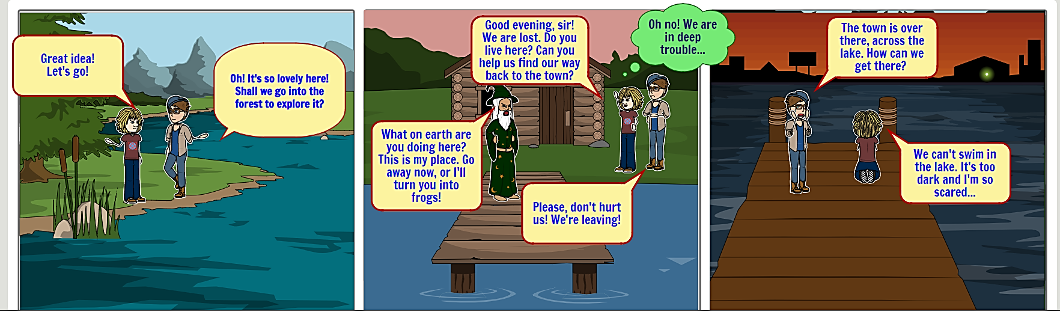
REMEMBER: Before you start writing ask yourself questions. Where?/When?/How?/Who?/What?/…
_One day two kids were went for a walk in the forest but they got lost. Then they found a magician. They asked him if he knew how to go back in their home but he started shouting and told to them that this is his own place and if they did not leave, he would turn them into frogs then the two kids were scared so they left. Then the kids saw their house across the lake. Some hours later, the magician saw them cried he was sorry so he built a bridge with his magic power. The two kids hugged him, thanked him and left.

Nice ending!
A

