Story Writing for ST’ Class Story 1 “An Adventure in the Forest”
*Read the comic. It’s the beginning of the story. Write the story based on the pictures and give your own ending.
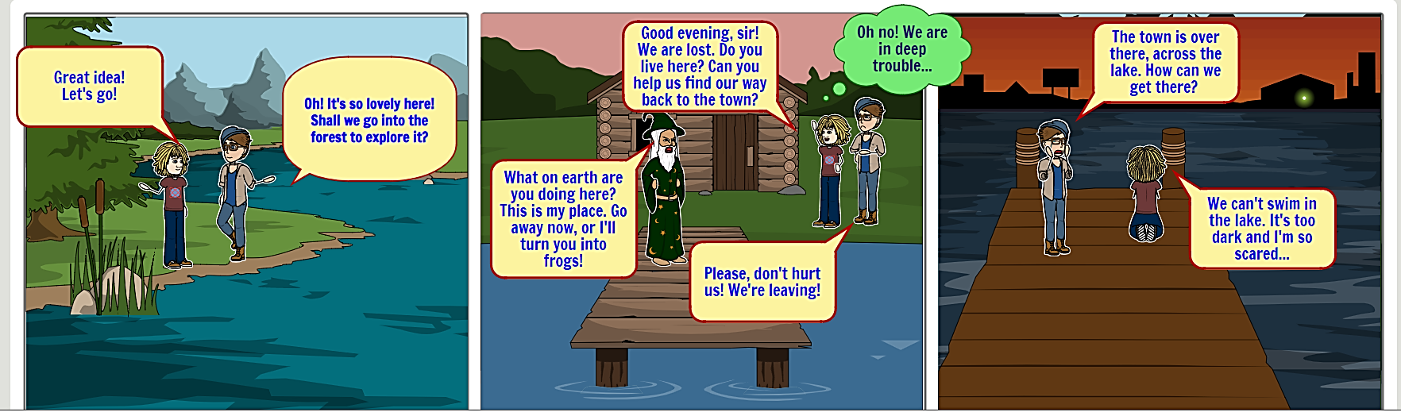
REMEMBER: Before you start writing ask yourself questions. Where?/When?/How?/Who?/What?/…
Maria and Nikos visited the lake a few months ago. They travelled by car and the journey lasted for two hours. They loved camping and the lake was a good spot to do that. They stayed there for two nights and explored even the forest close by. Unfortunately, when they decided to go back, they were already lost. Suddenly, they saw a strange man standing on the dock of the lake. He was dressed like a magician but he was a little bit scary. They asked him for instructions, but he seemed very angry. He also threatened them. “Go away now, or I’ll turn you into frogs” he said. Maria and Nikos were terrified and decided to go away even if they must/had to swim in the dark lake…..

