Story Writing for ST’ Class Story 1 “An Adventure in the Forest”
*Read the comic. It’s the beginning of the story. Write the story based on the pictures and give your own ending.
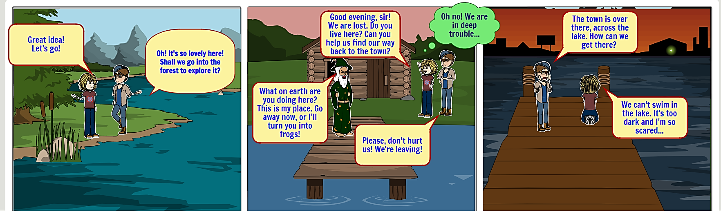
REMEMBER: Before you start writing ask yourself questions. Where?/When?/How?/Who?/What?/…
Suddenly a man in his boat reached a little further. The children saw him and made sense to help them. He came and told them that he would only help them if they got a precious, magic necklace that he has been trying to get back for a long time. The children accepted by force. They waited for the wizard to fall asleep to enter his house. As soon as he fell asleep they came in and his cat attacked them so they tried to get her out. They took the necklace and left, but the wizard managed to wake up. He took his wand and cursed the necklace and then the men threw it into the lake so that they wouldn’t get hurt. They reached the shore and the children thanked him and told him that they were sorry about the necklace. Finally they went to their house and slept and they lived well and we better. ____________________________________________________________________________________________________________________________________________________________________________________________________________________________________________________________________________________________________________________________________________________________________________________________________________________________________________________________________________________________________________________________________________________________________________________________________________________________________________________________________________________________________________________________________________________________________________________________________________________________________________________________________________________________________________________________________________________________________________________________________________________________________________________________________________________________________________________________________________________________________________________________________________________________________________________________________________________________________________

