2nd PRIMARY SCHOOL OF PYLAIA
5th GRADE
Title: GETTING TO KNOW KALOCHORI LAGOON

We recently visited it! We got informed by the Axios Delta National Park
Management Authority. We took the red path, we observed the
landscape, we enjoyed the flamingos, we felt the need to protect it…
It’s the Kalochori Lagoon, next to the Thermaic! It protects us from
extreme weather phenomena and disasters! It’s a habitat and resting
place for many of birds and an attraction for nature lovers.
It belongs to the list of the Ramsar Convention Wetlands of International
Importance especially as a waterfowl habitat.
It invites us to take action , to increase citizens’ awareness of the
wetlands’ importance to maintaining ecological balance.

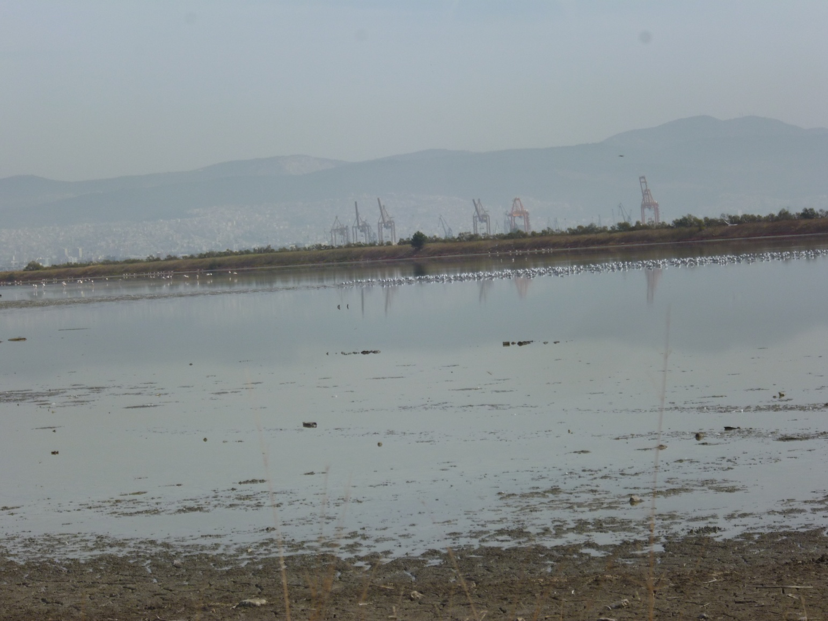
I am situated only eight kilometres from the centre of Thessaloniki with the port of Thermaikos in the background.

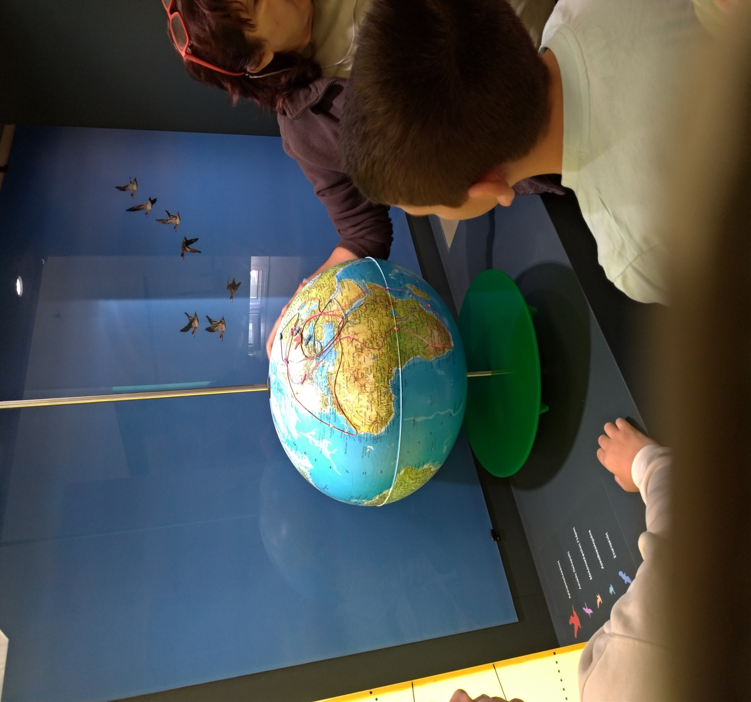
The Axios Delta Management Authority will inform you about my value as a popular migratory bird stopover site.
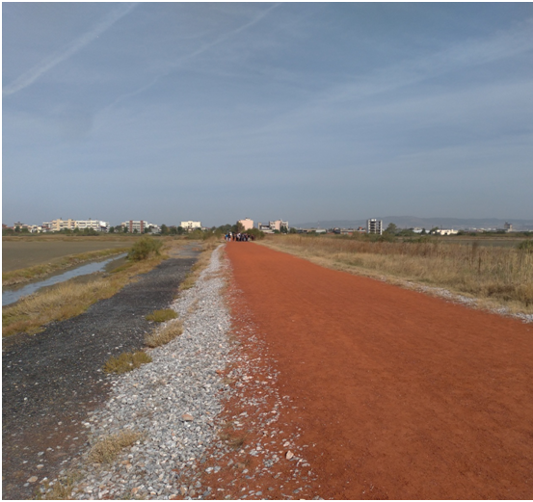
Walking on my famous “red path” you can enjoy the incessant sounds of birds in the peace and quiet of the landscape.

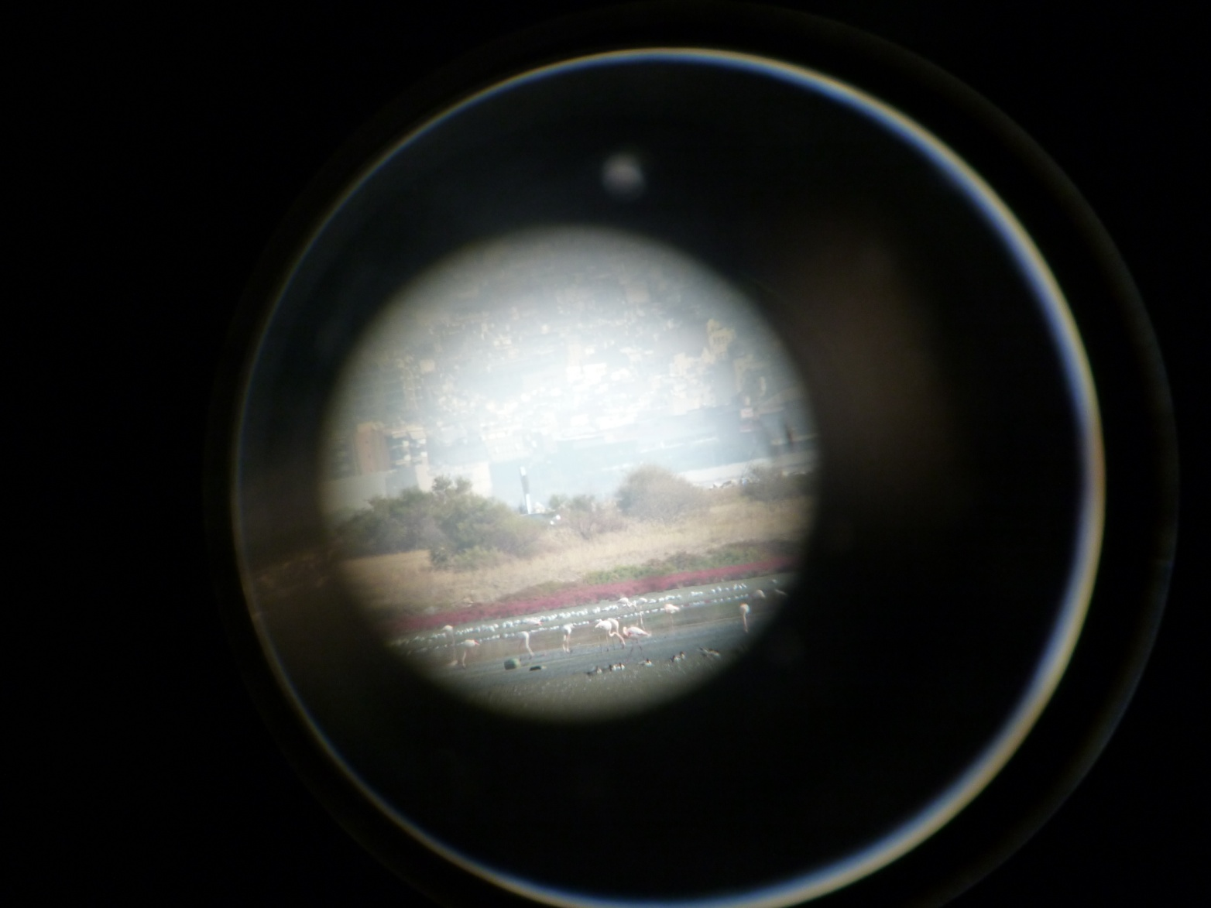
You can use telescopes or cameras to capture flamingos and other birds eating and resting in my calm waters

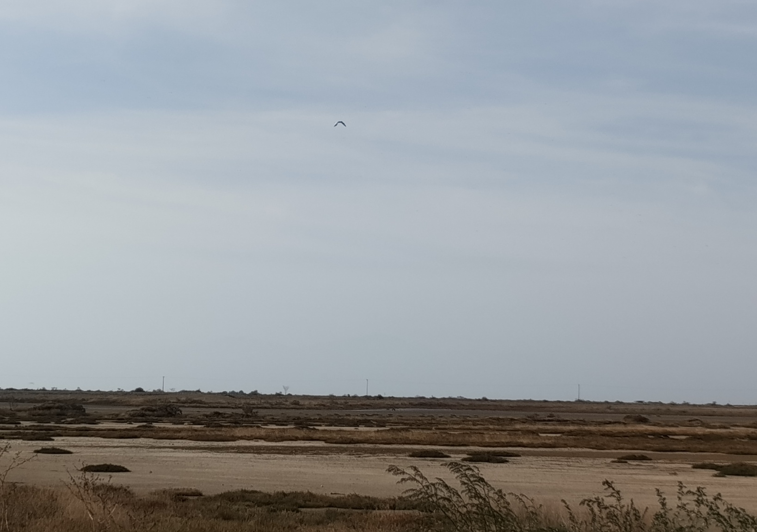
Visit me- Get informed-Admire me- Protect me so I can continue my work in maintaining the balance of the environment.

