THE TEMPEST
A play of William Shakespeare
Municipal theatre
Friday 23rd June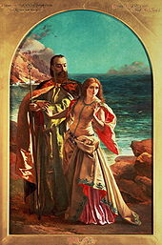
Time:20:00
All children let’s have fun!!!!

