ΑΓΓΛΙΚΑ ΣΤ1,2 ΔΗΜΟΤΙΚΟΥ-REVISION PART 3

EXERCISE 1:The following sentences are in the wrong order. Number them so they are in the right order.(Οι προτάσεις είναι σε λάθος σειρά.Αρίθμησέ σωστά)
A DAY IN MY LIFE
_____ I watch TV for one hour.
_____ I have dinner at 6:00 PM.
_____ I brush my teeth and eat breakfast.
_____ I have lunch at 12:30 PM.
_____ I do my homework after watching TV.
_____ I have Math and English lessons in the morning.
_____ I go to bed.
_____ My mother picks me up after school.
_____ I get up in the morning.
_____ I have music and computer lessons in the afternoon.
_____ My mother drives me to school.
_____ I go to sleep.
_____ I read a story book in bed.

EXERCISE 2):READING TIME!!Read about Tom’s day and then write about your day.
TOM´S DAY

I always get up at seven o'clock. Then I eat breakfast. I usually eat bread and drink a glass of milk. Then I feed the cat. I always eat lunch at eleven forty five. At lunch time I usually drink coke and eat a bowl of rice. I usually have dinner at six o'clock in the evening.
Later, I do my homework and go to bed. I often go to bed at nine o'clock.

EXERCISE 3):Write the nationalities next to the countries.
1. | Great Britain | a. | Dutch
2. | Portugal | b. | Spanish
3. | Russia | c. | British
4. | Holland | d. | Swiss
5. | Germany | e. | Russian
6. | Switzerland | f. | Portuguese
7. | Spain | g. | French
8. | France | f. | German
EXERCISE4):Watch the video on YouTube and do the exercises.
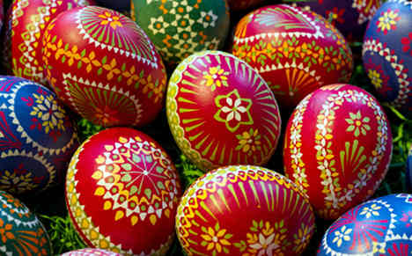
A British Easter: Traditions
https://www.youtube.com/watch?v=UWtMkskB2Qg

A)Read the sentences and say if they are True (T) or False (F).

- The rabbits protect the eggs when you are on an easter hunt. _______
- In Easter, people feel the same excitement as in Christmas. _______
- Around Britain, you can find lots of chocolate eggs all over the shops. ______
- Chocolate eggs are the only Easter desserts. _______
- The egg hunt takes place inside their houses. _______
- Eggs remained with the same shape while decorating them. _______

B)Read the definitions and complete with the suitable word.

Easter Bunny Competition - rebirth - Greeting Easter Card -
Hot Cross Bun

- A little cake marked with a cross traditionally eaten on Good Friday.
_____________________.
- A kind of letter that you send to your relatives to wish them a good Easter.
_____________________.
- A synonym of resurrection. In Easter, it is of Jesus Christ.
_____________________.
- A creative activity about decorating hats with chicks, eggs...
_____________________.

