ΑΓΓΛΙΚΑ ΣΤ1,2 ΔΗΜΟΤΙΚΟΥ-REVISION PART 5
PART A:DO THE EXERCISES!!!!!!
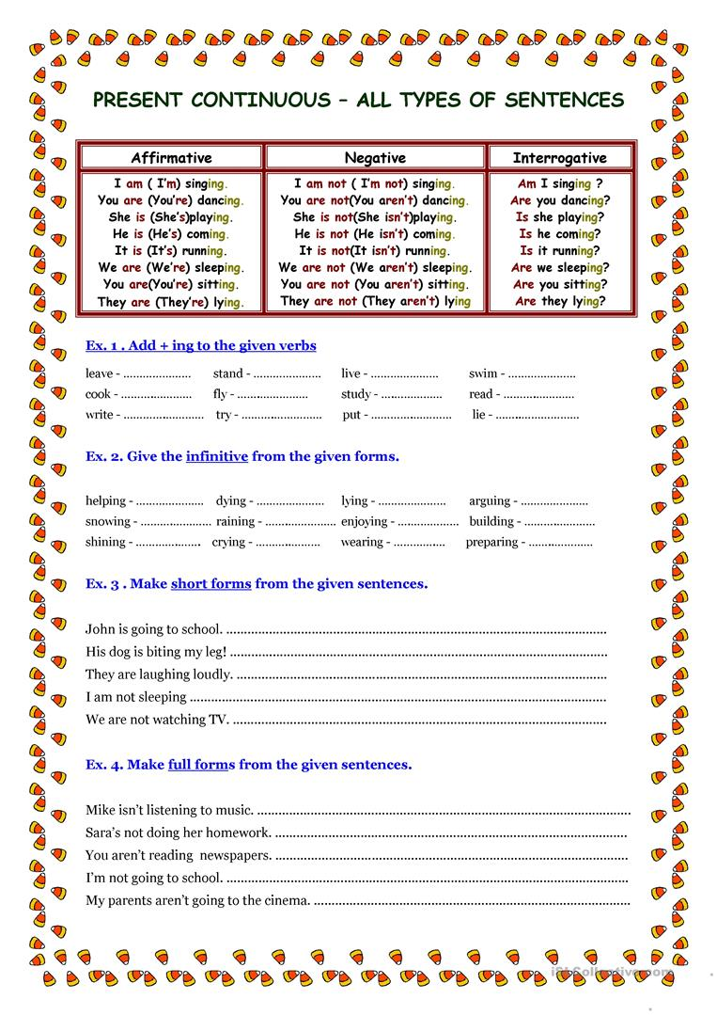

PART B:Can you fill the phrases with the correct preposition of time?
1)___ Monday 6)___ 2019
2)___ the evening 7)___ February 12th
3)___ night 8)___ Easter Sunday
4)___ Christmas 9)___ 3 o’clock
5)___ May 10)___ summer

PART C:Follow the link and do the exercises.
a)https://www.liveworksheets.com/worksheets/en/English_as_a_Second_Language_(ESL)/Feelings_and_emotions/Feelings_and_emotions_xj302xv

