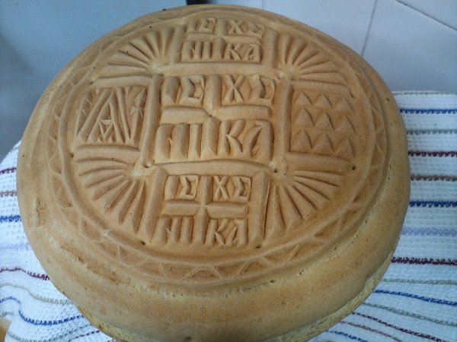

CUSTOMS-TRADITION
What is Holly Bread (Prosforo)? The term Proforo (or offering, liturgy, or reference) originally meant an offering that was made, but in Orthodox Christianity, it ended up symbolizing the bread, that is, the Holy Bread that we offer to the church. It is a kind of gratitude and devotion to God through a voluntary offer.

What do the patterns and designs on the Holly Bread stand for? The offering has a round shape, symbolizing the womb of the Virgin Mary, and features a relief design in the shape of a cross. The relief design is made with a special wooden stamp. In the center are the initials IC CHR NI KA (Jesus Christ Victory). This is the part that is destined to become the Body of Christ. The triangular piece on the left side encloses the letters M and Θ (i.e., Mother of God), which are attributed to the Virgin Mary. On the right side of the liturgy, there is a square piece with nine small triangles, which represent the parts of angels and saints.

Which peoples make Holly Bread?
The preparation of the Holly Bread is traced to peoples of the Eastern Orthodox Church.
Russia,Serbia,Ukraine,Romania

