**ΑΓΓΛΙΚΑ Ε1,2 ΔΗΜΟΤΙΚΟΥ-REVISION PART 10**

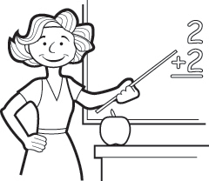Exercise A:Write the verbs in Present Continuous and Simple Present.

This is Mrs White. She …………… (be) a primary school teacher.

She …………………………… (teach) English, Maths and Geography.

At the moment, she …………………………… (teach) . She …………………………… (live) in London and ………………… (be)married to Georges, who is French. They …………………………… (have) three children. They all …………………………… (love) animals, but they …………………………… (not have) any pets because they …………………………… (live) in an apartment. Mrs White ……………………… (speak) French as well as English, but she …………………………… (not teach) it.

=====

Mrs White’s niece Sophie …………………………… (stay) with the Whites for a few days. Sophie …………………………… (live) and …………………………… (study) in Liverpool, but she ……………………………… (enjoy) her mid-term break in London at the moment. She …………………………… (plan) to do some serious shopping and sightseeing.

=====

Mrs White’s son Arnold …………………………… (not like) shopping, but he …………………………… (love) hanging out with friends. They usually …………………… (go) to the local park where they ……………………… (play) football or basketball.

Today, however, Arnold ……………………………….…. (not play) football or basketball; he …………………………….. (skateboard).

=====

Mr White ………………… (work) for a multinational company. He ………………………… (not work)

today, however, because he ……………………………. (not feel) well. He phoned in sick.

Exercise B:Follow the link and do the exercises.

<https://learnenglishkids.britishcouncil.org/sites/kids/files/attachment/grammar-practice-present-simple-and-present-continuous-2.pdf>