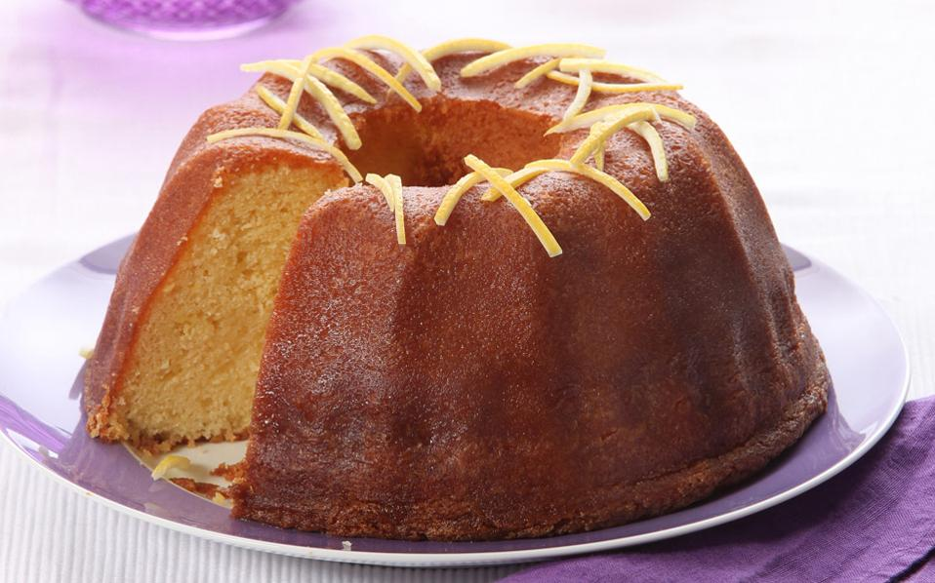

Cake
Ingredients
- Eggs
- Flour
- Milk
- Sugar
- Butter

Method
- Heat the oven to 160^{O} C.
- Mix together the sugar, butter, eggs and milk. In a large bowl. Add the flour.
- Beat thoroughly. Pour butter evenly into the prepared baking trays.
- Bake for 45 minutes.

