Τετάρτη 1 Απριλίου 2020
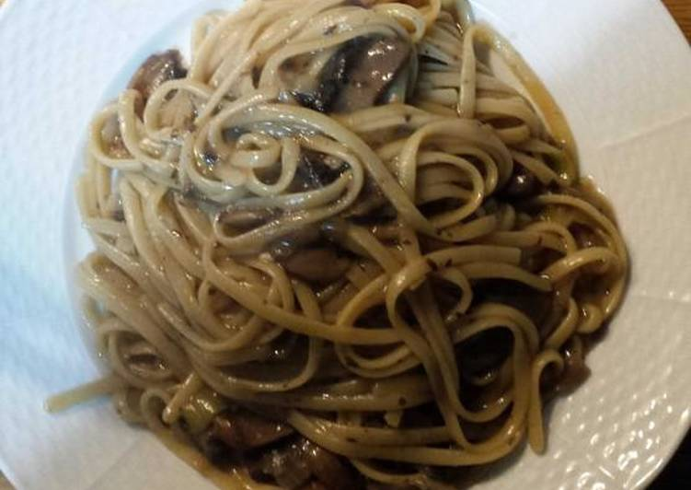
Ingredients
- 1/2 kilo of spaghetti
- a spoon full fo salt
- 1/ 2 kilo of mince
- 1 onion
- 3 tomatoes some sugar
Instruct citrons
First, boil ten spuabetti then drain tens spaghetti
Next, pour some olive oil in ten pun add ten spaghetti
Aftertnar , slice the anion and pour oil into ten frying pans. Then grate the tomatoes and add all the ingredients into the fraih pan. Boll them until the water finishes. Finally, serve the spaghetti with mince in a Piute.

