Units 1 – 2 -3
- Read about Planet Earth and complete the correct word.

atmosphere  ocean surface terrestrial system

Our home planet Earth is a rocky ……………………………………………… (geoid) planet. It has a solid and active surface with mountains, valleys, canyons, plains and so much more. Earth is special because it is an ……………………………………………… planet. Water covers 70% of Earth's ……………………………………………….
Earth's ……………………………………………… is the right thickness to keep the planet warm so living things can be there. It is mostly nitrogen, and it has plenty of oxygen for us to breathe. It’s the only planet in our solar ……………………………………………… we know of that supports life.
Time on Earth
When we talk about how Earth and the other planets travel around the Sun, we say they orbit the Sun. Earth rotates once on its axis per day. When you think of a day, you normally think of one cycle of daytime to nighttime. That is called a solar day. On Earth, a solar day is around 24 hours. However, Earth’s orbit is elliptical, meaning it’s not a perfect circle. So, some solar days on Earth are a few minutes longer than 24 hours and some are a few minutes shorter.
One year on Earth lasts 365.25 days. That 0.25 extra means every four years we need to add one day to our calendar. We call it a leap day (in a leap year).

- a year of 365 days ………………………………………………
- revolve ………………………………………………
- spins around itself ………………………………………………
- an imaginary line running through the earth poles ………………………………………………

2. Draw and write on the photos

The lines that run from the north to the south pole are called meridians.
The Prime Meridian runs through Greenwich in London England
It divides the earth into the west and the east hemisphere.

The lines that run east and west each have a constant latitude value and are called parallels. They are of equal distance, parallel to one another, and form concentric circles around the earth. The Equator is the largest circle and divides the earth into the north and the south hemisphere,

co-ordinates

Latitude is which parallel a place is in.
It is the distance of the place south or north from the Equator. We measure Latitude in degrees.
0º to 90 º degrees in the north
0 º o to 90 º degrees in the south
The Equator’s latitude is 0 º degrees.

Longitude is which meridian a place is in. It is the distance of a place west or east from the Prime Meridian.
0º to 90 º degrees in the west
0 º to 90 º degrees in the east
The Prime Meridian’s longitude is 0 º degrees.
3. Write the degrees of the spot
on the globe

………………………………………………………..longitude
…………………………………………………………latitude
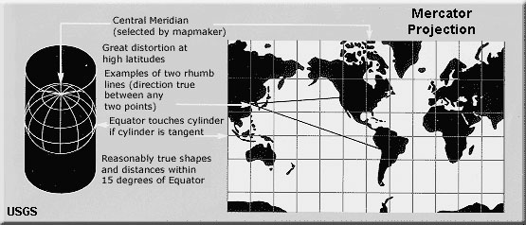
The Earth on paper

round flat
Geographic projections are a way of showing the curved surface of the Earth on a flat surface like a piece of paper or a computer monitor.
Co-ordinates are
180º+180º=………… º from east to west (latitude)
90 º +90 º = …………. º from north to south (longitude)
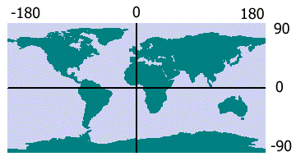

The E_____________

The P_______ M____________

Task 1: Look at the flat map (Mercator). Read the Global Positioning System (GPS) co-ordinates. Can you spot the country?

latitude 39º North, longitude 22 º East
54 º N 2 º E
38 º N 97 º West
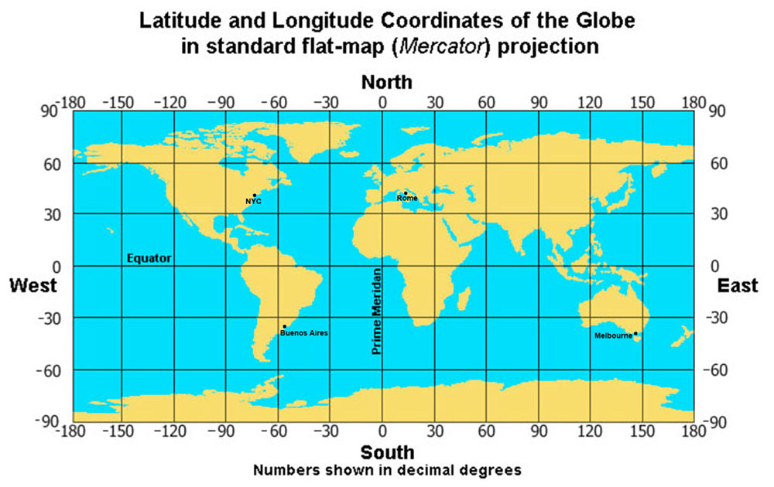

Task 2: Answer the True – False.
- The Earth axis is imaginary.
- Earth rotates on its axis from west to east once in about 24 hours.
- The meridians connect the two poles.
- The Earth’s parallels are concentric circles.
Unit 4 Earth Axis, Rotation, Day & Night Cycle

The part of the Earth which
doesn’t face the Sun has
____________.

The part of the Earth which
faces the Sun has ________.

While (=καθώς) the Earth rotates continuously (=αδιάκοπα) on its _____________, the Sun shines in different places, one after the other. So, daytime comes after nighttime.
How long does a day last?
The duration of a day is approximately (= περίπου) 24 hours. Why?
This is because the Earth is slightly t____________ on its axis,(=έχει μια μικρή κλίση).
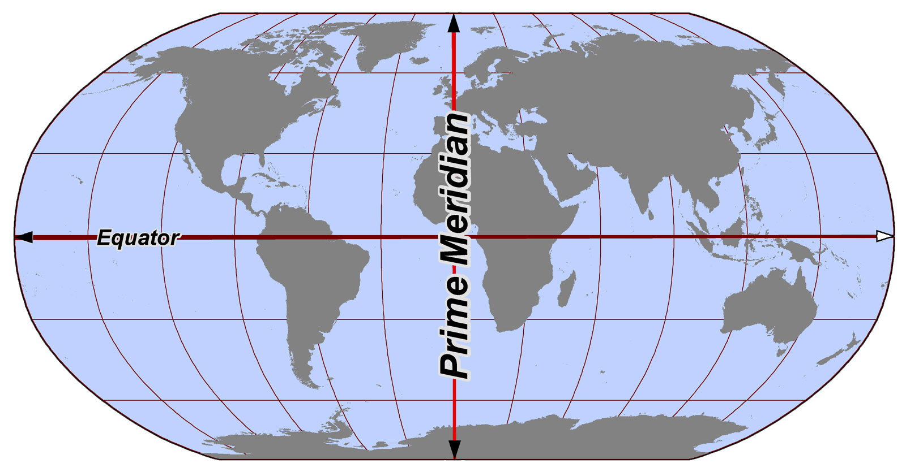
The North Hemisphere
June 21st or 22nd Summer Solstice
December 21st or 22nd Winter Solstice

June 21st or 22nd Winter Solstice
December 21st or 22nd Summer Solstice

Twice a year the Sun is at the furthest from the Equator.
So the longest day of the year is on …………………………….. and the shortest on ……
http://photodentro.edu.gr/v/item/ds/8521/3271
https://www.suncalc.org/#/36.8374,23.5195,3/2021.10.08/18:23/1/2

Unit 5

Seasons are four recurrent(επαναλαμβανόμενες) time periods every year. Seasons are characterised by the same weather conditions (t_____________s , sunlight, rainfall, winds) more or less.
Why do we have seasons?
The Earth’s rotation axis is t___________ (πλάγια) causing its revolution around the Sun to be e____________al. As a result, the heat from the Sun is not the same each time period in each hemisphere.

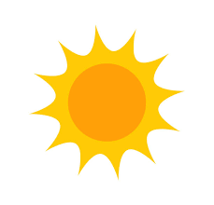

https://www.youtube.com/watch?v=d7zzn1QjzwY

- The northern hemisphere is nearer / further from the Sun. The sun rays are vertical (=direct) / at an angle (=fall sideways). In the NORTH POLE the temepratures are low / high and the days / nights last 6 months.

Γ. The southern hemisphere is nearer / further from the sun. The sun
rays are vertical (=direct) / at an angle (=fall sideways). In the
SOUTH POLE the temepratures are low / high and the days / nights last 6
months.

- In the Equator, the sun rays always fall __________________. The temepratures are low / high and it’s always winter / summer.

https://www.youtube.com/watch?v=Pgq0LThW7QA

Lesson 6 Our galaxy

Task A. Match
planet a. producing its own light
b. getting its light from another star
satellite c. round mass of rock and metal, such or of
hetero luminous gas that moves in a circular path around
the sun or another star
self-luminous d. a round mass revolving round / orbitting
a planet or star
Question
Why are planets named after Greek gods / goddesses or have names of Greek origin?
………………………………………………………………………………………………………………………………………………………….
…………………………………………………………………………………………………………………………………………………………..
Task B: Fill in the missing word
The Sun is a big ________________ and it is s_______ -________. E_________ big planets orbit the sun. Planets are h___________-l__________ ( the sun lights and heats them). These planets are (starting from the one closer to the sun):
Mercury Venus The Earth Mars JupiterSaturn Uranus Neptune

Match the Greek names
Αφροδίτη Δίας
Ποσειδώνας
Ερμής
Γη
Άρης
Κρόνος Ουρανός
https://spaceplace.nasa.gov/menu/solar-system/

Lessons 9-10

The Atmosphere
What I know about the Earth’s atmosphere. True or false?
- The atmosphere surrounds the earth at 1000 klms high above the Earth’s terrain. 
- The atmosphere is divided into imaginary, consecutive layers. 
- Troposphere (the lower layer) is where the weather phenomena happen. 
- The ozone layer can’t absorb Sun’s ultraviolet rays. 
- The heat from the sun destroys life on the earth. 

Why is the atmosphere called the Earth’s shield?
oxygen  ultraviolet  climate  meteorites
- It contains the dangerous ______________ Sun’s rays which can destroy life on Earth.
- It protects the Earth from the.
- It protects the Earth from extreme ________________change (sudden and steep rise or fall in the temperature).
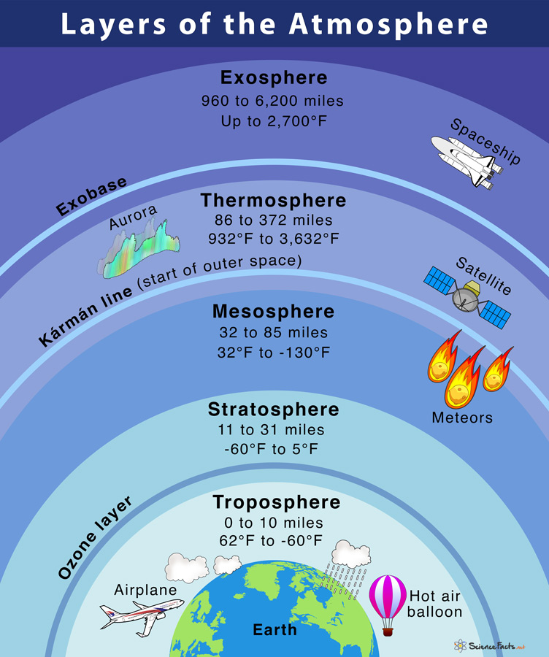
- It provides ___________________ for our breathing.

Climate zones are areas with distinct climates, which occur in east-west direction around the Earth, and can be classified using different climatic parametres. Generally, climate zones are belt-shaped and circular around the Poles (see picture). In some areas, climate zones can be interrupted by mountains or oceans.
The solar radiation (The Sun’s rays) reaches the ground on different parts of the Earth with different angles. On the equator, the sunlight reaches the ground almost vertically, whilst at the poles the angle of the Sun is lower or even under the horizon during the polar night.
Throughout the seasons, the position of the Sun to the Earth. So, the angle of incidence of the sunlight also change. The angle of the Sun at noon varies from perpendicular (90°) within the tropics up to horizontal (0° = Sun does not or only partially appear on the horizon) within the polar circle. Thus, the sunlight warms up the Earth around the equator much more strongly than at the poles. Due to temperature differences caused by the differences in radiation, recurring climatic conditions develop, such as winter and summer. These conditions are characterised by a certain amount of precipitation in summer or a certain average air temperature.
Different climatic conditions, which arise regularly in certain areas, are summarised and described in the classification below.

Classification
There are 4 major climate zones:
- Tropical zone from 0°–23.5°(between the tropics)
  - In the regions between the equator and the tropics (equatorial region), the solar radiation reaches the ground nearly vertically at noontime during almost the entire year. Thereby, it is very warm in these regions. Through high temperatures, more water evaporates and the air is often moist. The resulting frequent and dense cloud cover reduces the effect of solar radiation on ground temperature.
- Subtropics from 23.5°–40°
  - The subtropics receive the highest radiation in summer, since the Sun's angle at noon is almost vertical to the Earth, whilst the cloud cover is relatively thin. These regions receive less moisture (see trade winds), what increases the effect of radiation. Therefore, most of the deserts in the world are situated in this zone. In winter, the radiation in these regions decreases significantly, and it can temporarily be very cool and moist.
- Temperate zone from 40°–60°
  - In the temperate zone, the solar radiation arrives with a smaller angle, and the average temperatures here are much cooler than in the subtropics. The seasons and daylength differ significantly in the course of a year. The climate is characterised by less frequent extremes, a more regular distribution of the precipitation over the year and a longer vegetation period - therefore the name "temperate".
- Cold zone from 60°–90°
  - The polar areas between 60° latitude and the poles receive less heat through solar radiation, since the Sun has a very flat angle toward the ground. Because of the changes of the Earth axis angle to the Sun, the daylength varies most in this zone. In the summer, polar days occur. Vegetation is only possible during a few months per year and even then is often sparse. The conditions for life in these regions are very hard.

